**Group 4 - Insurance Portal**

**Problem Statement:**

The Vehicle Insurance Management System has been developed to override the problems prevailing in the existing manual system. So, the idea is to automate the existing manual system by developing full-fledged, error free, secure, reliable online solution that can store non-redundant and valuable data for a longer period and provide good performance and better services to the customer.

According to existing system, the agent would act as a mediator between the insurer (service provider) and the insured(Customer). It leads to excess charges of payment in terms of brokerage and token money to the Customer. Also, there are no means for tracking status of the insurance application issued for the Customer. The Customer validation is done only via staff of the service provider.

The proposed vehicle insurance policy system is a web-based application that aims to develop a complete and fully functional independent system to manage records of vehicle insurance companies. It is developed with the intent of providing such insurance companies and online platform for accurate processing, organized data handling and efficient retrieval and storage of records.

The Key Features of the Proposed System are:

* Proper management of vehicle insurance details like add new vehicle details, modify existing records, delete existing records etc.
* Non-motor insurance details option in insurance category for customers to provide their details and personal information.
* Report Generation Feature for every data and record entered into the system database.
* Use of Report Generation module to add, modify and delete records to/from the database.

**Flow Of Insurance Portal**

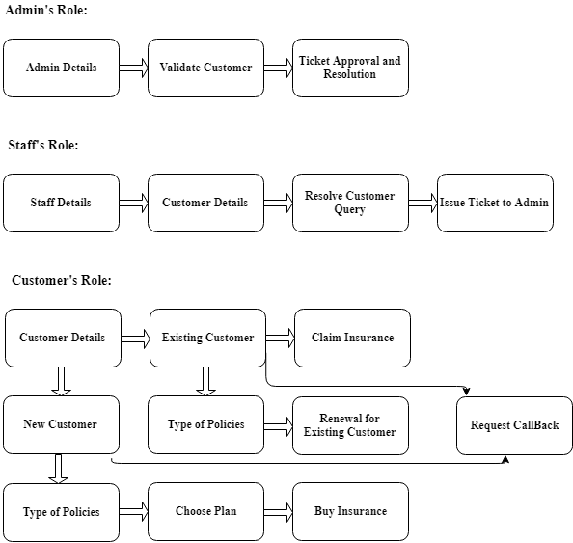

**Home page**

This Home page includes the Company name, Login option, Contact details of the Admin. From About us option we get the details of the Site.

**INSURANCE** **PORTAL**

FOUR WHEELER

LOGIN

News

MOTOR INSURANCE

CONTACT US

SITEMAP

ABOUT US

HOME

KEY FEATURES NEW PLANS/OFFERS

Description

REGISTRATION FORM FOR NEW USER

DOB

ADDRESS

CONTACT NUMBER

EMAIL ID

NAME

REGISTRATION FORM

SUBMIT

SECURITY QUESTION?

**LOGIN FORM**

LOGIN ID

PASSWORD

FORGOT PASSWORD

SUBMIT

LOGIN PAGE

**Forgot Password**

LOGIN FORM

SUBMIT

Confirm Password

New Password

Answer

Choose Security Questions

**ADMIN DASHBOARD**

The Admin is responsible for Staff Registration, Ticket approval, Report generation and User validation. All the query operations approval and final report checks are provided by the Admin.

* Staff Registration: All the Staff Details are registered in the admin portal.
* Ticket Approval: Tickets issued by the staff are approved by the Admin
* Report Generation: Details of the customer, their policy plans and payment slips are generated
* User Validation: Registered customers are validated by admin for confirmation of their account

Address: 

ADMIN

Report Generation

User Validation

Ticket Approval

Staff Registration

**STAFF DASHBOARD**

* This is staff login. Here staff would be able to view their profile.
* Staff would also be responsible for calling the customer in case request call back is requested and resolve the query and provide suitable information to the customer.
* Staff is responsible for issuing the tickets for the customer in case the customer faces any login problem like account locked, not able to login, etc.

**Staff DashBoard**

**Customer Queries**

**Profile**

**Issue Tickets**

**Customer Details**

**New User DashBoard**

On this page user will enter his profile details. Then user will select a plan as per his desire. Then user will proceed to payment gateway.

If user have any query regarding the plan, then he can select request call back option. On receival of request our staff will call user and resolve his/her query.

Welcome User

Request Call back

Profile

Choose Plan

Buy Plan

**Existing user page:**

* Here existing user can view his/her profile and track their insurance status.
* User can claim for their insurance policy.
* Also User can renew their existing policy.

Welcome User

Profile

Claim

Track Status

Renewal

User

Customer_Profile

Admin

Staff

Car_Insurance